
Work Instruction for LUN Reclamation for existing partitions in Virtual Server

Viatris
Work Instruction for LUN Reclamation for existing partitions in Virtual Server

Contents
Contents 2
1. Introduction 3
1.1. Purpose 3
1.2. Scope of this Report 3
1.3. Audience 3
2. Approach and Methodology 3
2.1. Approach 3
2.2. Methodology 3
2.2.1. Validation & Pre-checks 3
2.2.2. LVM & Filesystem Cleanup 4
2.2.3. OS Device Removal 4
2.2.4. VMware Reclamation 4
2.2.5. Post-Implementation Validation 4
2.2.6. Documentation and Compliance 4
2.2.7. Rollback Plan 4
3. Technical Details 5
3.1. Current Volume Mapping 5
3.2. Pre-Check Commands 5
3.3. Unmount Filesystems 7
3.4. Remove Logical Volumes 8
3.5. Delete Devices from Kernel 8
3.6. Remove VMDKs from VMware 9
3.7. Post-verification 10
4. Roles and Responsibilities 11
5. Escalation Matrix 12
6. Revision History 12

1. Introduction

1.1. Purpose
This document will provide the procedure to be followed for LUN Reclamation for existing partitions in Virtual Server based on the requirement.

1.2. Scope of this Report
The purpose of this guide is to provide details on LUN Reclamation for existing partitions in Virtual Server.

1.3. Audience
GIDC UNIX Group

2. Approach and Methodology

Approach
- Identify and verify the target mount points and logical volumes.
- Gracefully unmount the file systems.
- Remove the LVM configuration from the OS.
- Remove the devices from the OS kernel.
- Reclaim space by deleting VMDKs from VMware/vCenter.

Methodology

2.2.1. Validation & Pre-checks
- Create and document a CR in ServiceNow with all relevant details and obtain approvals.
- Confirm mount points are unused.
- Validate volume mappings and dependencies.
- Backup current configuration.

2.2.2. LVM & Filesystem Cleanup
- Unmount mount points.
- Remove logical volumes, volume group, and physical volumes.

2.2.3. OS Device Removal
- Remove device files from the OS using the delete SCSI interface

2.2.4. VMware Reclamation
- Remove associated VMDK disks from the VM via vCenter.

2.2.5. Post-Implementation Validation
- Log Review:
Check system logs for any warnings or errors related to the deleted disks.

2.2.6. Documentation and Compliance
1. Document the implementation process with detailed steps, commands, and screenshots where applicable.
2. Ensure compliance with organizational change management and auditing requirements.

2.2.7. Rollback Plan
Maintain a clear rollback plan, leveraging the backups of the deleted disks and adding the removed disks if required.

Technical Details
This section outlines the exact technical steps, commands, and outputs associated with the reclamation of the LUNs backing the /Hyperion, /HyperionData, and /HyperionBackup mount points.

Current Volume Mapping
The mount points are associated with logical volumes configured under the volume group appvg. The mappings are as follows:
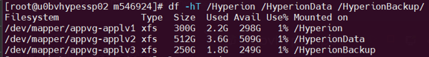
These volumes are configured using LVM and are currently mounted with the XFS filesystem.

Pre-Check Commands
Run the following commands to validate current mount points, filesystem types, and logical volume configurations.
# Display all block devices and their mount points
lsblk
# Show disk usage with filesystem types
df -hT
# List volume groups and their attributes
vgs
# List logical volumes and their sizes
lvs
# List physical volumes (underlying devices)
pvs
# Check if any processes are using the mount points
lsof /Hyperion /HyperionData /HyperionBackup
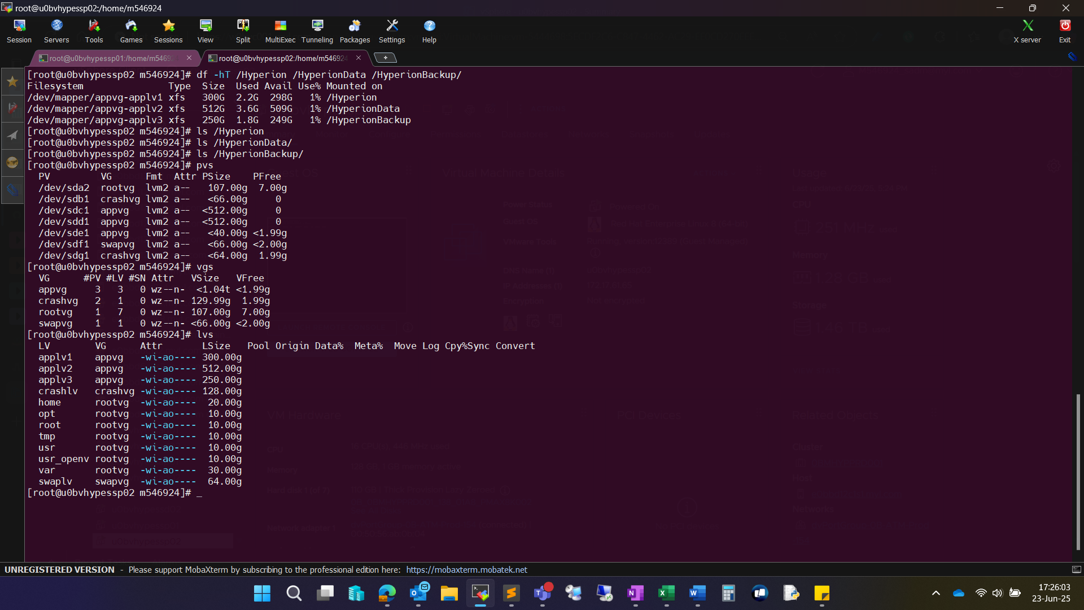

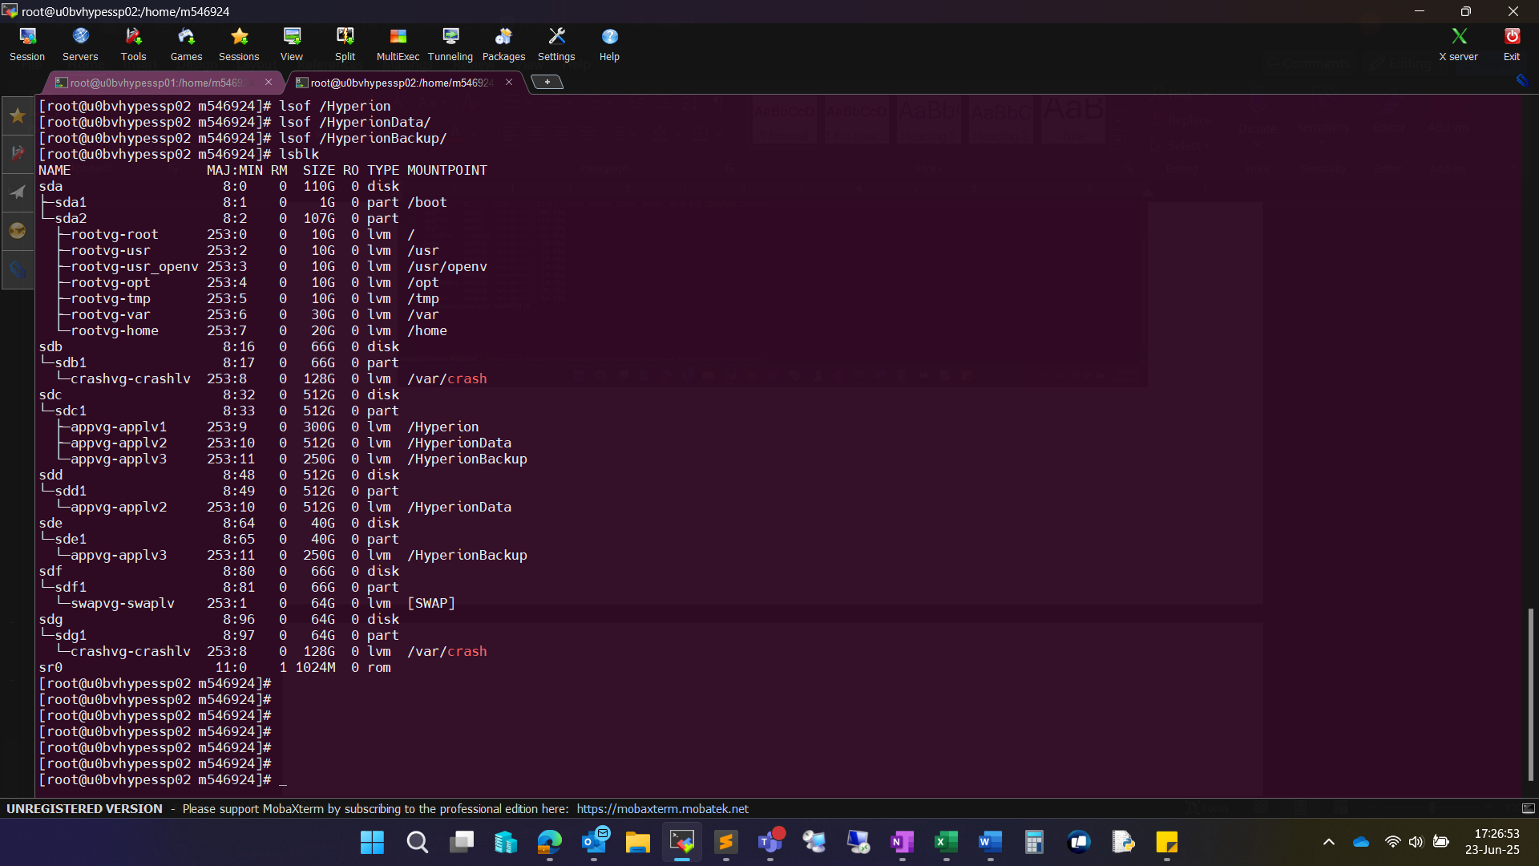
Ensure that no application is actively using these volumes and that data is backed up or no longer required.

Unmount Filesystems
Once validated, unmount the filesystems in the correct order to avoid application errors.
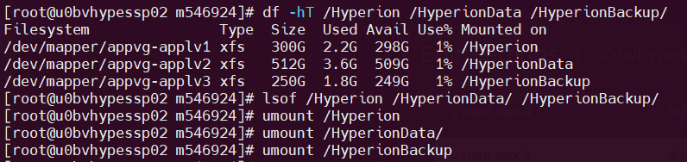
After unmounting, verify with df -hT output. The mount points should no longer appear in the output.

Remove Logical Volumes
- Remove the logical volumes associated with the unmounted filesystems.
- If there are no other logical volumes remaining in the volume group appvg, you can safely remove the volume group
- Next, remove the physical volume mappings associated with the deleted volume group
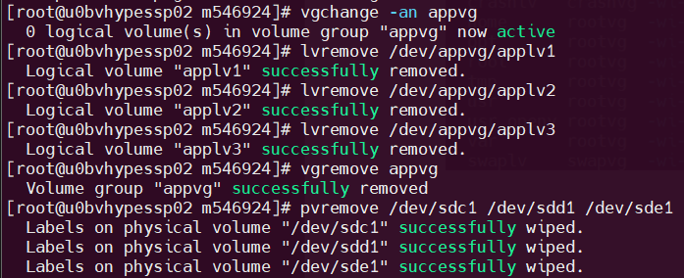

Delete Devices from Kernel
After removing LVM structures, clean up the device entries from the OS using the SCSI delete command.
This command instructs the kernel to remove the block device (e.g., /dev/sdX) from the system without needing a reboot.

Remove VMDKs from VMware
To reclaim the storage space, log into vCenter and follow these steps:
- Login to vcenter with sadm account and password
- Open the VM configuration in vCenter.
- Click Edit Settings.
- Identify and select the disks matching the deleted LUNs (use size/device name for reference).
- Click Remove and select:
Remove device and data
This step reclaims the actual disk space from the virtual environment.
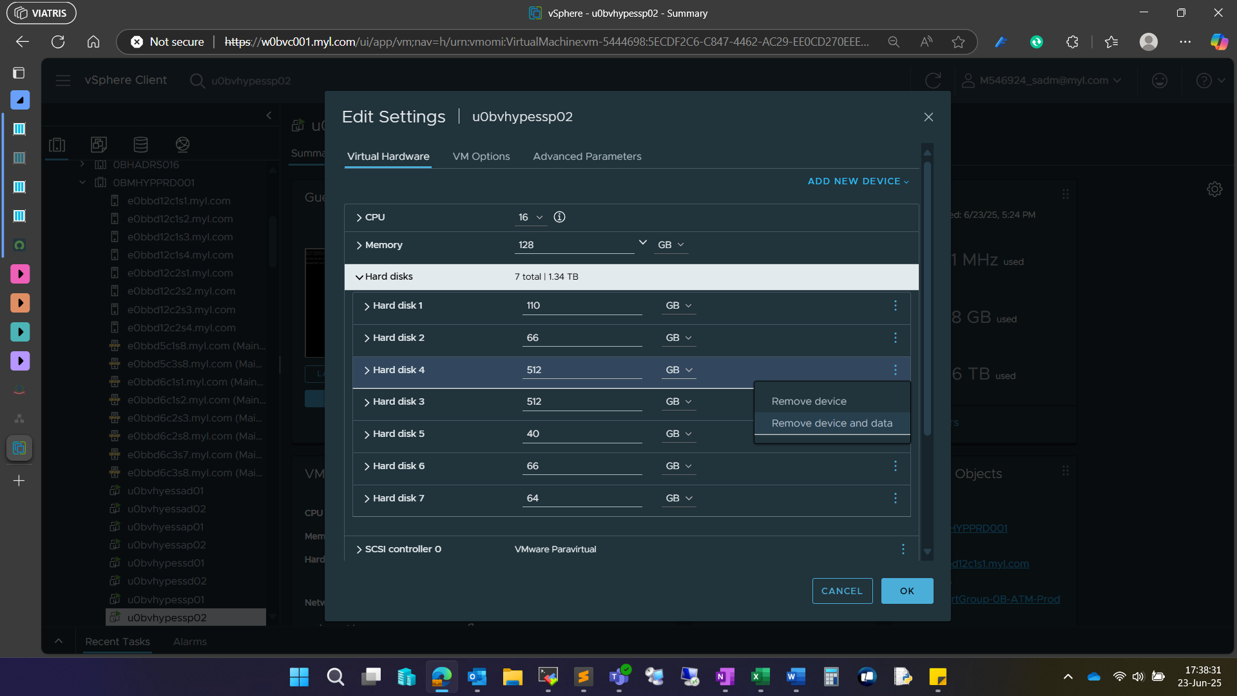

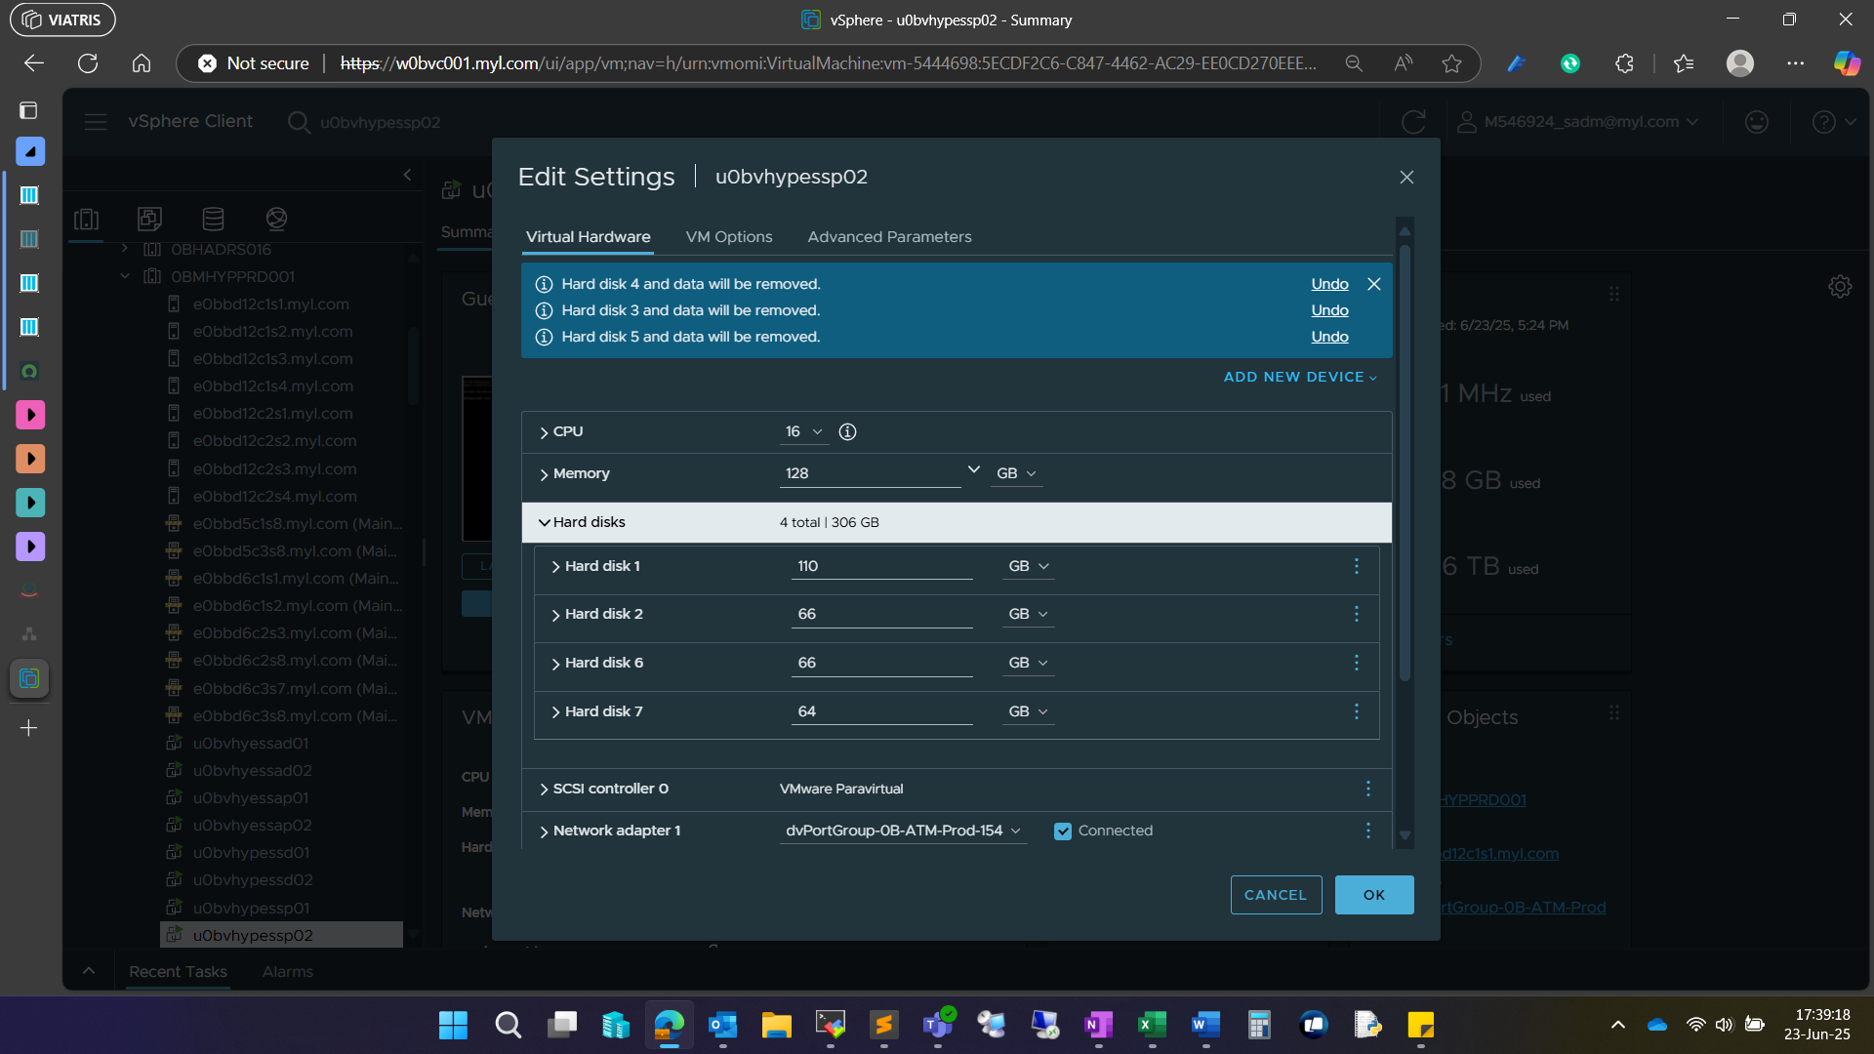

Post-verification
- Check that the physical devices (e.g., /dev/sdX) associated with the reclaimed LUNs are no longer visible in the system.
- Ensure no residual logical volumes, volume groups, or physical volumes are present using lvs, vgs and pvs command.
- Check the /etc/fstab file for any obsolete mount entries corresponding to the reclaimed mount points. Remove all entries related with the removed mount points to prevent boot-time mount failures.
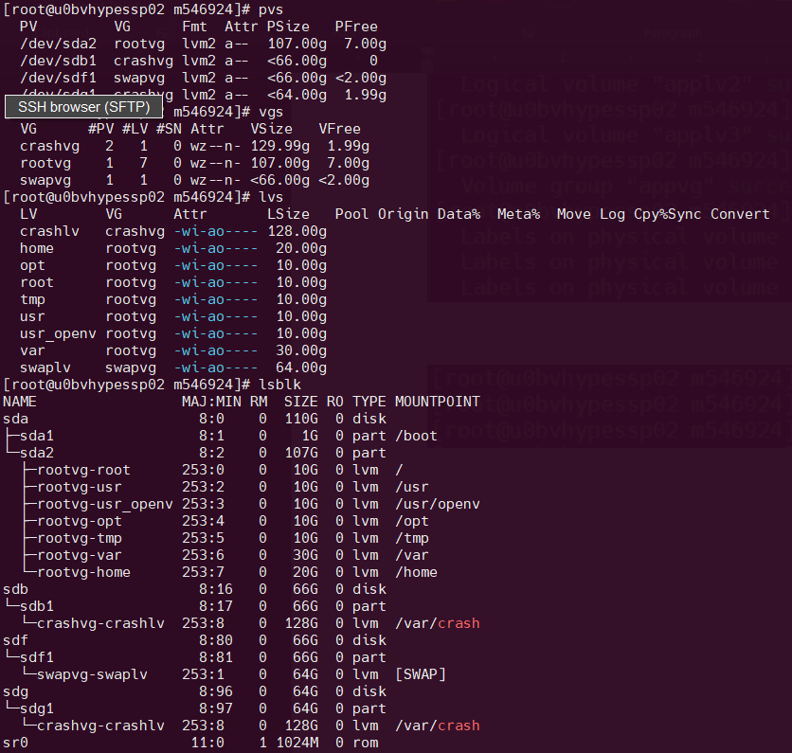

Roles and Responsibilities
Sl. No. | Roles | Responsibilities | Team Member Name
1. | Change Request | Respective Team / Unix Team | GIDC.unix_Run  GIDC.unix_Run@viatris.com
2. | Change Implementation | Respective Team / Unix Team | GIDC.unix_Run  GIDC.unix_Run@viatris.com

Escalation Matrix
Person Responsible | Role | Triggers When
Arun R  Arun.R@viatris.com  +91 9710677240 | Deputy Manager
Ashok Kumar R K  AshokKumar.RK@viatris.com  +91 9967735890 | Senior Manager
Zahir Hussain M ZahirHussain.M@viatris.com  +91 9840689462 | Senior Manager

6. Revision History

Date | Version | Summary of Changes | Author | Approved by
July 06 2025 | V1.0 | Created the Document | Benesh Selva Nesan P | Arun R
April 28 2026 | V1.1 | Validated the Document | Benesh Selva Nesan P | Arun R

